Table of Contents

Introduction 2
Problem Definition 2
Aim and Objectives 3
Scope 3
Methodology 4
Data Sources 5
Expected Deliverables 5
Project Timeline 8
Ethical and Legal Considerations 8
References 10

Introduction

This project aims to predict whether a small accommodation/hotel with six rooms, located above a pub named The Merry Cobbler in Dublin 4, will reach full occupancy during the summer season by using historical data.
The Merry Cobbler is a pub and accommodation/hotel located in a prime location on Irish Town Road in Dublin 4. It has convenient and easy access to public transport to the city centre and the main attractions in Dublin. It is also within walking distance of Sandymount Beach, the Aviva Stadium and the 3Arena. The pub was purchased in 2016, while the accommodation was only opened last year.
For this project, historical booking data from the accommodation's first year of operation will be used and analysed to identify useful patterns associated with full occupancy. These patterns will help determine the factors that contribute to all six rooms being booked at a particular time during the summer season and may help the business identify and optimise opportunities to increase occupancy.
The project is relevant to the business because the accommodation is relatively new and operates in a competitive hospitality environment. The information collected and analysed will help the business identify opportunities, improve the management and operation of the accommodation.

Problem Definition
The business operates in a highly competitive environment, as it is relatively new to the market, has limited amenities to offer, and has limited previous experience in the accommodation sector. The accommodation is located above a pub, which can be noisy on certain nights and may potentially affect the guest experience. In addition, it is located in an area with several competing accommodation options that may offer more amenities at a similar or higher price. These factors may affect its competitiveness and customers’ booking decisions, particularly when compared with alternative accommodation in the same area.

After collecting, organising, analysing, and interpreting historical data (Data Analytics), such as past occupancy and reservation patterns, predictive modelling can be used to forecast future outcomes. This may include predicting cancellations and no-shows, as well as demand forecasting, such as estimating the probability of achieving full occupancy, which is the main aim of this project.

Aim and Objectives
The primary goal of this project is to analyze historical booking and occupancy data and develop a predictive model to estimate the probability of the small hotel reaching full occupancy during the summer season. It is a fundamental and essential task for the hotel management to estimate the occupancy rate as it greatly influences the hotel revenue.
Therefore, this project also aims to contribute to operational efficiency, to support marketing planning, to improve pricing strategies, to support making strategic choices and to gain a competitive advantage. The main objectives that must be met to be able to achieve this are as follows:
• Collect, organize, analyze and interpret historical data to identify relationships and trends that influence occupancy trends.
• Build a predictive classification model to predict the probability of the hotel reaching full occupancy on the preprocessed data set and provide business insights and recommendations that could help in improving customer satisfaction.
• Analyze customer behavior, competitor offers and retention strategies to know about factors that may influence customers’ booking decisions and occupancy levels.

Scope
The project will focus on developing a model to predict whether a small accommodation establishment, consisting of six rooms, will reach full occupancy during the summer season using historical data.
The project will primarily use historical data from the accommodation establishment. However, if the available data from pulse website is not sufficient, additional data from the accommodation market will be used to complement the analysis.
Included
- Capstone Project: Select and specify the project to be presented in the capstone, including the problem definition, goals, methodology, data sources, and anticipated deliverables.
- Problem Understanding and Definition: Problem Definition and Understanding: The project's main goal is to forecast a six-room pub's summertime full occupancy.
- Data Collection: collect, organize, and clean up both past and present lodging information, such as reservations, occupancy, availability, room rates, booking dates, and more.
- Model Building: Select an appropriate machine learning model and build, train, and test it. Several models may be compared; however, as this is a classification problem, the Random Forest Classifier will initially be used. In hospitality, classification models can predict whether a customer will book a room, the likelihood of repeat visits, or whether a guest will leave a positive or negative review.
- Model Evaluation: Use suitable evaluation measures, such as a confusion matrix and recall, to assess the model's accuracy and performance.
- Results Communication: Share the model's findings and offer insights that can help with decision-making and lead to better business outcomes.
- Model Monitoring and Updating: Depending on the model's performance and the availability of fresh data, review and update it as needed.
Not included
The following data will not be analyzed:
- Names, phone numbers, and email addresses that are specific to the owner or visitors.
- Sensitive personal data.
- Information unrelated to the accommodation analysis or the objectives of the project.

Methodology
Describe how you plan to carry out the project. Explain the proposed data analytics methods, predictive modelling techniques, technologies and tools, and briefly justify your choices.
Include a high-level architectural diagram showing the proposed workflow or system architecture and how the main components are connected. Briefly explain the main components and overall workflow.
- Booking volume by date
- By segment and channel
- With cancellations and no shows layered in
- So you get a net occupancy forecast, not just gross bookings
https://www.researchgate.net/publication/385384852_Prediction_of_Booking_Trends_and_Customer_Demand_in_the_Tourism_and_Hospitality_Sector_Using_AI-Based_Models
https://www.lsbronline.com/wp-content/uploads/2025/01/Predictive-Analytics-and-Forecasting-in-Hospitality.pdf

Data Sources

For this project, the dataset will consist of historical reservation and occupancy data from The Merry Cobbler's Booking.com Pulse account, which is used by the owners to manage the accommodation. The data may include:
- Reservations
- Occupancy
- Availability
- Room prices
- Booking dates
- Guest confirmations
- Property performance
The data sources will therefore include The Merry Cobbler's Booking.com Pulse account, Booking.com, and other publicly available sources.
The data will be analysed to identify patterns in historical bookings and occupancy and to develop a predictive model to determine whether the accommodation is likely to reach full occupancy on a given date.
The owner consented to the use of the data under the General Data Protection Regulation (GDPR). The owner was assured that the data would be used solely for academic purposes and that the security, integrity and confidentiality of the data would be maintained throughout the project.

Expected Deliverables
Clearly state what you expect to produce by the end of Semester 2, including the expected analytical and predictive modelling outputs and any relevant dashboard, application, system or other project deliverables.
By the end of Semester 2, a data analysis and predictive modelling solution is expected to be developed to predict whether the small accommodation will reach full occupancy on a given date. This will help the hotel owner protect revenue by supporting pricing decisions, optimise resource management through staff planning, maintain service quality by reducing waiting times, and also improve marketing strategy.
To enhance data visualisation, a dashboard will be developed to facilitate data interpretation and enable the quick identification of trends, anomalies, and opportunities.
The finished predictive modelling will show how machine learning and data analytics can help a small company with occupancy planning and well-informed decision-making.

Project Timeline
The project timeline for both semesters is shown in the Gantt chart below. The specified dates could change as the project progresses. Predictive modeling, evaluation, data collection, and preparation will be the main tasks of this capstone project.

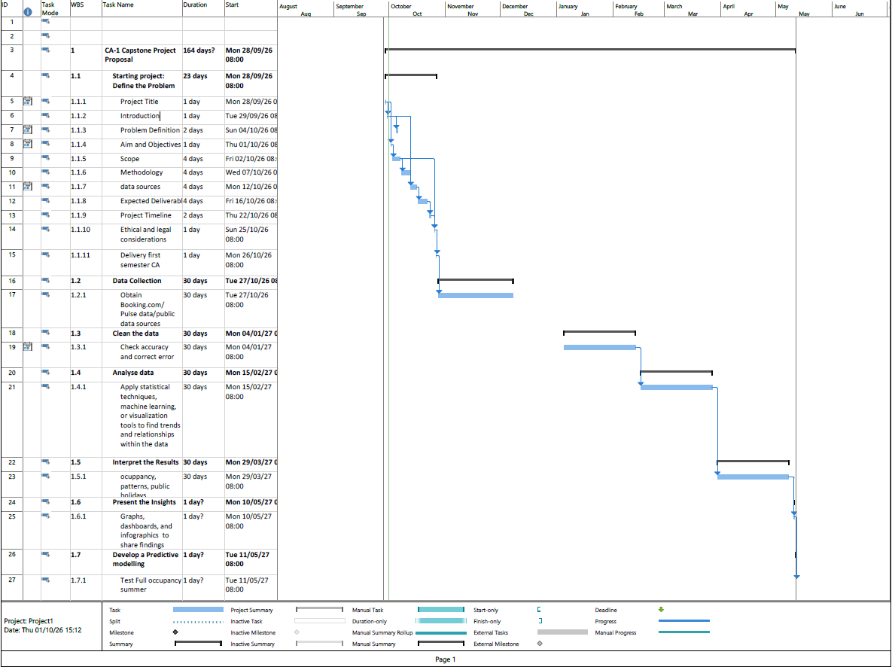

Ethical and Legal Considerations
The project will follow the principles of the General Data Protection Regulation (GDPR), particularly regarding the legitimate purpose of data processing. The data will be used only for the purpose of the Strategic Thinking CA’s. Only the data necessary to make this project possible will be collected and processed. Personal data such as guests' names, dates of birth, email addresses, phone numbers, and other identifying information will not be necessary for this project. However, all data collected from the company will be handled securely, ensuring its security, integrity, and confidentiality.

Permission to access and use the business data has been obtained from the owner/manager.

References
Finn, T. and Smalley, I. (2024) What is predictive analytics? Available at: https://www.ibm.com/think/topics/predictive-analytics (Accessed: 28 september 2026).

Booking.com (no date) The Merry Cobbler, Dublin: guest reviews. Available at: https://www.booking.com/hotel/ie/the-merry-cobbler.html (Accessed: 1 October 2026).

Steps of Data Analysis for Predictive Analytics & Business Insights. Available at: Identifying a Business Problemhttps://thevistaacademy.com/data-analysis-process-steps/(Accessed: 1 October 2026).
Ahmed, Taufique. (2026) Identifying a business problem. Data Analytics for Business. CCT College Dublin. Available at: https://moodle.cct.ie/my(Accessed: 1 October 2026).

Carneiro T, Picoto WN, Pinto I. Big Data Analytics and Firm Performance in the Hotel Sector. Tourism and Hospitality. 2023; 4(2):244-256. https://doi.org/10.3390/tourhosp4020015

D. Pramita, N. W. Saraswati, I. P. Sandana, P. Pirozmand, and I. K. Bisena, ”Optimizing Hotel Room Occupancy Prediction Using an Enhanced Linear Regression Algorithms”, MATRIK: Jurnal Manajemen, Teknik Informatika, dan Rekayasa Komputer, Vol. 24, No.1, pp. 95-104, November, 2024.This is an open access article under the CC BY-SA license (https://creativecommons.org/licenses/by-sa/4.0/)
Ahmed, Taufique. (2026) Strategic Business & Professional Development. CCT College Dublin. Available at: https://moodle.cct.ie/my(Accessed: 5 October 2026).

Alex Carter, (Oct 1, 2024) Predictive Analytics in Project Management: Guide. Available at https://daily.dev/blog/predictive-analytics-in-project-management-guide/
Hassan, Muhammad ,Updated on: June 28, 2026. Predictive Analytics – Methods, Models, Examples, and Uses Available at https://researchmethod.net/predictive-analytics/
London School of Business and Research, UK, Predictive Analytics and Forecasting in Hospitality
LatentView Analytics ,Last Updated on February 16, 2026,Predictive Analytics in Hospitality: Use Cases, AI and Hotel Optimization Available at https://www.latentview.com/blog/predictive-analytics-in-hospitality/

